**Requirements for Sneaker bot:**

* **Inputs:** the user will enter the url of the shoes they want, user will enter shoe size, user will enter nike account email and password, user will enter billing information.
* **Outputs:** After entering information the website will display pop up that information has been received and processing is taking place. Once the transaction is either successful or unsuccessful a message will be displayed to the user. Confirmation of purchase will be sent to the user via Nike.
* **Data system must store:** System will store account information along with shoe attempts.

**Functional requirements:**

* Users will be given information in regards to if shoes are still available or are sold out**.** This information will be displayed in a pop up along with if the users purchase was successful or not.
* Users should be able to cancel transactions at any time before payment processing has occurred.

**Design constraints: Categories constraining environment and technology of system**

* **Website will be compatible with all major operating systems.**
* **Technology used will be React and Node.js for front and back end.**

**Commercial constraints: Categories constraining project plan and development methods**

* **Cost and delivery date**
* **Development process (methodology) that will be used**

**Requirements for Account Creation**

* **Inputs:** user with login into their gmail account to create an account on the website.

**Non Functional requirements:**

* Security requirement include system not displaying any sensitive user information.
* Sensitive information will be encrypted in database.
* Application will be easy to navigate and utilize.
* Payment and billing information must be encrypted to prevent any breaches, risks, and financial losses.

**Requirements Engineering Process**

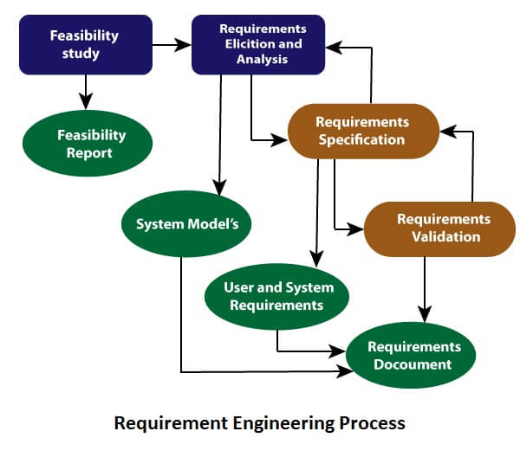

**Feasibility Study**

* **Is system worthwhile and doable ?**

**Requirements Analysis – Potential Problems**

* **User is not satisfied with the bots attempt to make purchases**
* **Scalability**
* **User wants to make multiple purchases simultaneously**